Your coworkers helping you train at ClimateWins have used optimization techniques before on other information. They want to start investigating how they can use the same methods for the weather data landscape you’ll be working with. Are simple differentiable functions enough, or do they need to have more processing power available for nondifferentiable functions? That’s the question of the hour!
As a test, they’ll be looking at a sample of temperature data from one of the weather stations in Europe from your scaled climate data set in your ”Data Sets” folder (not the “supervised” or “unsupervised” folders). ClimateWins wants you to use a gradient descent function on the temperature data to see how well it works and whether it can be incorporated into larger machine learning functions. This will help drive which program and algorithm they’ll ultimately pick.
Directions
- You’ve been given a more powerful script used for gradient descent optimization. Your task is to begin integrating it with the climate data. The last person to use it left a lot of descriptive comments, and you’ll need to use the directions to guide you. Before getting started, download the script.
- This data set uses a 3D visualizer and the plotly library. You can install it like you do any other Python library with either pip install plotly==5.12.0 or conda install -c plotly plotly=5.12.0
- Load your scaled data set as a “.csv” file in a new Python script.
- Follow the instructions included in the script to look at a year of temperature data for one of the weather stations.
- If done correctly, your loss function should look something like this (depending on where theta0 and theta1 start): 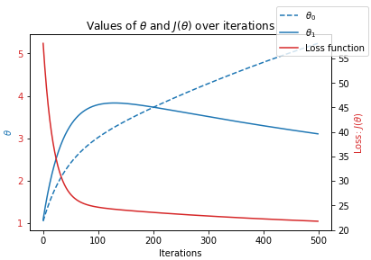
- While your loss profile will look something like this: 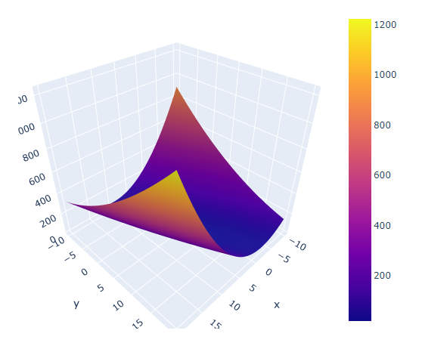
- Investigate at least three different weather stations and three different years and find values where the gradient descent converges.
  - Take screenshots of the loss function and profiles (similar to the images above) and paste them in a document along with the starting and ending theta0, theta1, iterations, and step sizes for each year and station you investigate.
  - Write at least three observations about the weather station temperatures over the span of 60 years.
- Upload your completed Jupyter script along with the document of your findings and observations for your tutor to review.

